Aut

Figure Successfully got a JWT Token using Windows Logon

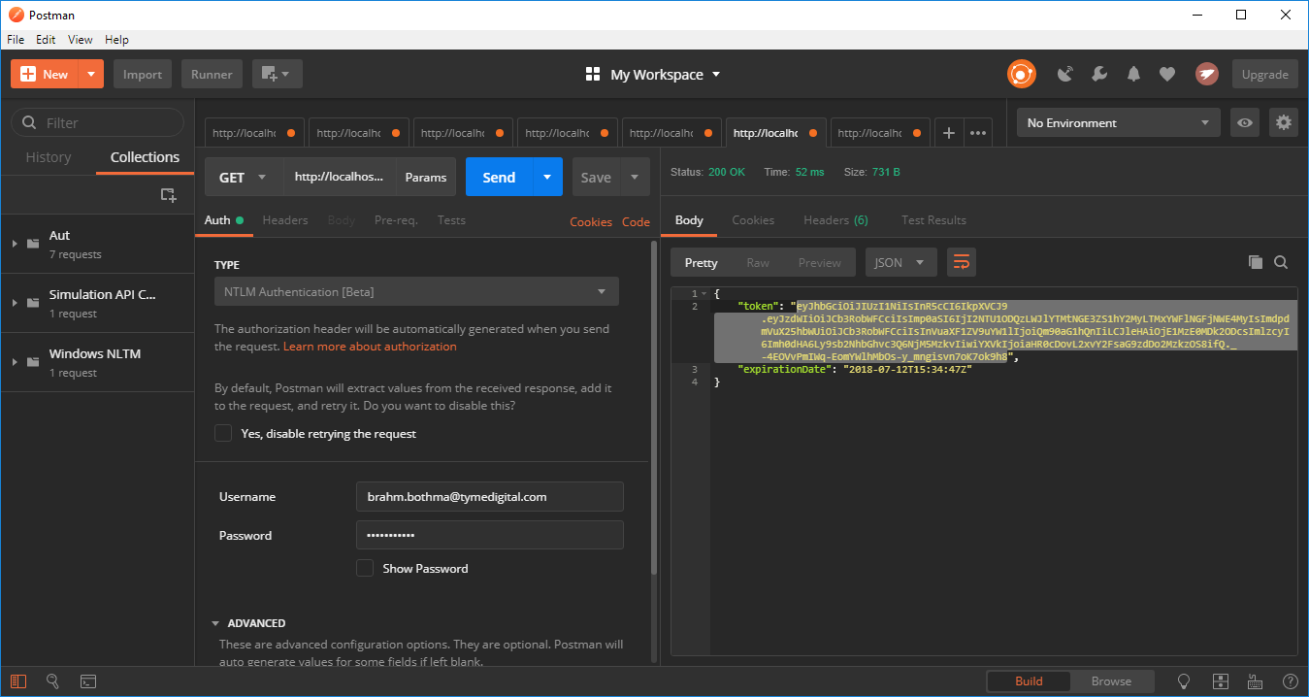

Figure Using JWT got data

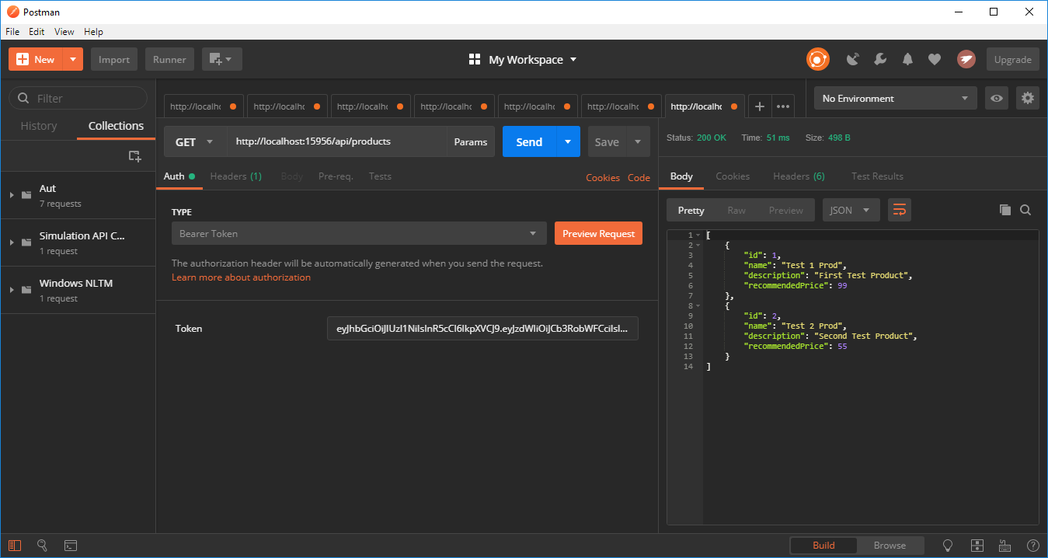

Figure Still got additional data using the same JWT

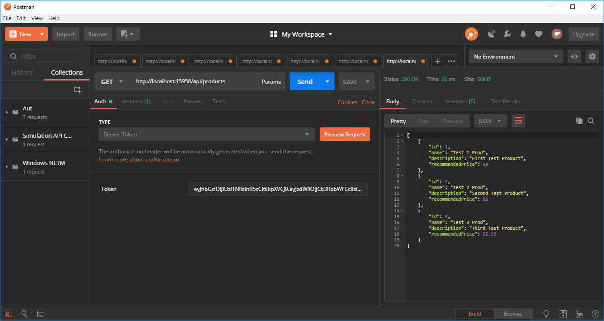

Figure Token successfully expired

